Ref.J.6
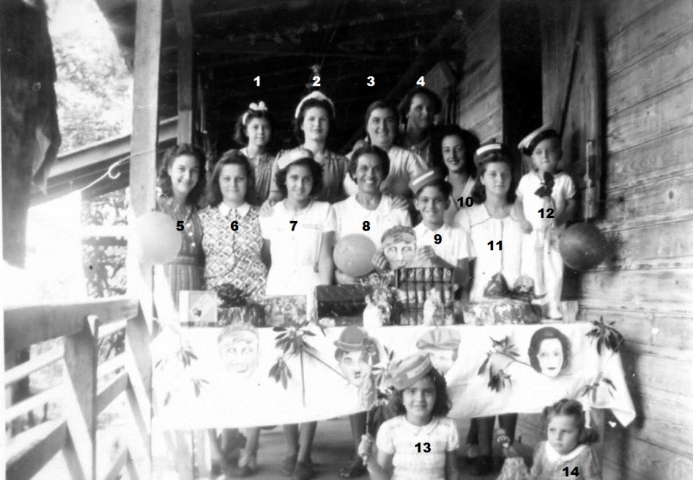
3.M.Orcese 7. P.Romero 8.Mrs L Romero 10. M.Dalmedo (later Mrs Frolic).

Ref .J.7
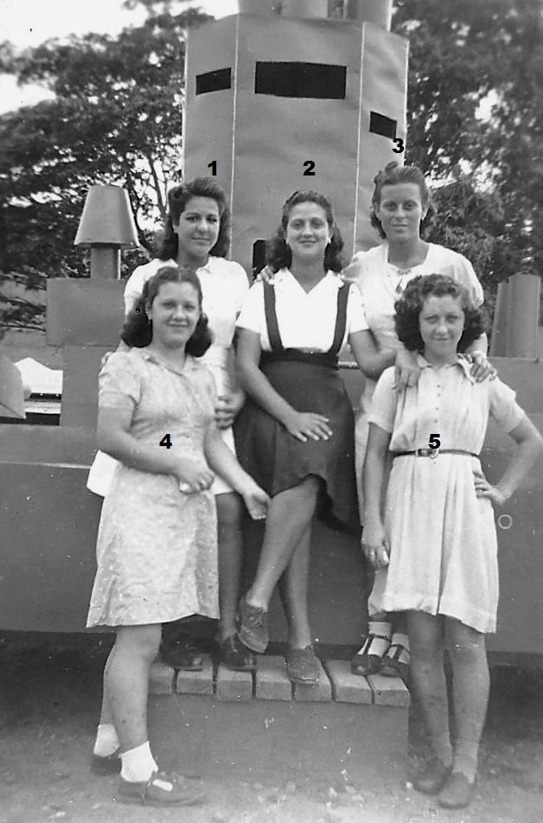
J.2. 1.Aida Alman,2. Olga Dalmedo,3. Hortencia Besura
4 ? 5 ?

