Ref.J.10
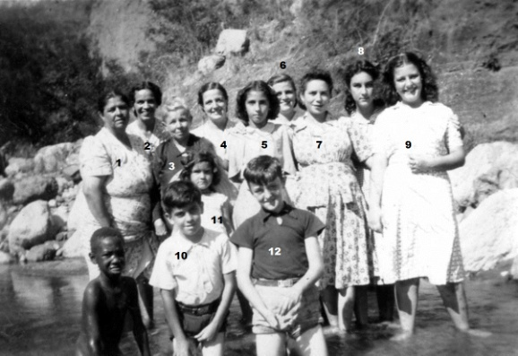
2 .Mrs L.Romero,6. Mrs C Gomez 8. Lourdes Orcese rest unknown

Ref.J.11
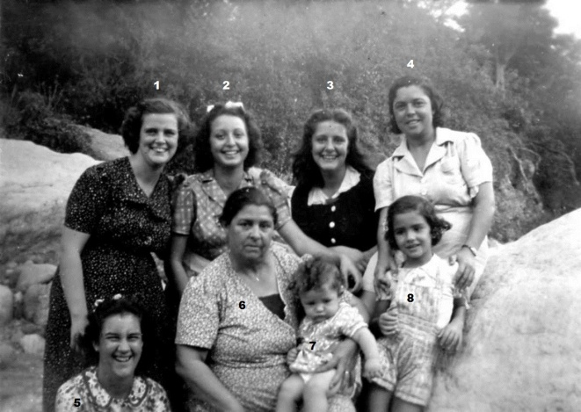
1. Mrs C Gomez ,2.Celecia 3. ? 4 Pepi Zammitt
5. Lourdes Orcese 6. ? 7 ? 8. ?

