Ref.J.20
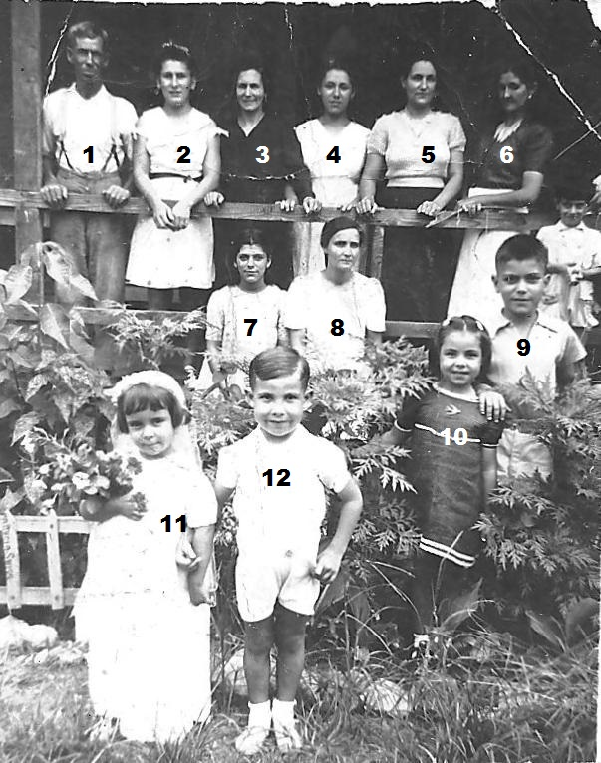
11. Rosita Gilbert 12.John Enriles rest not known.

Ref.J.21
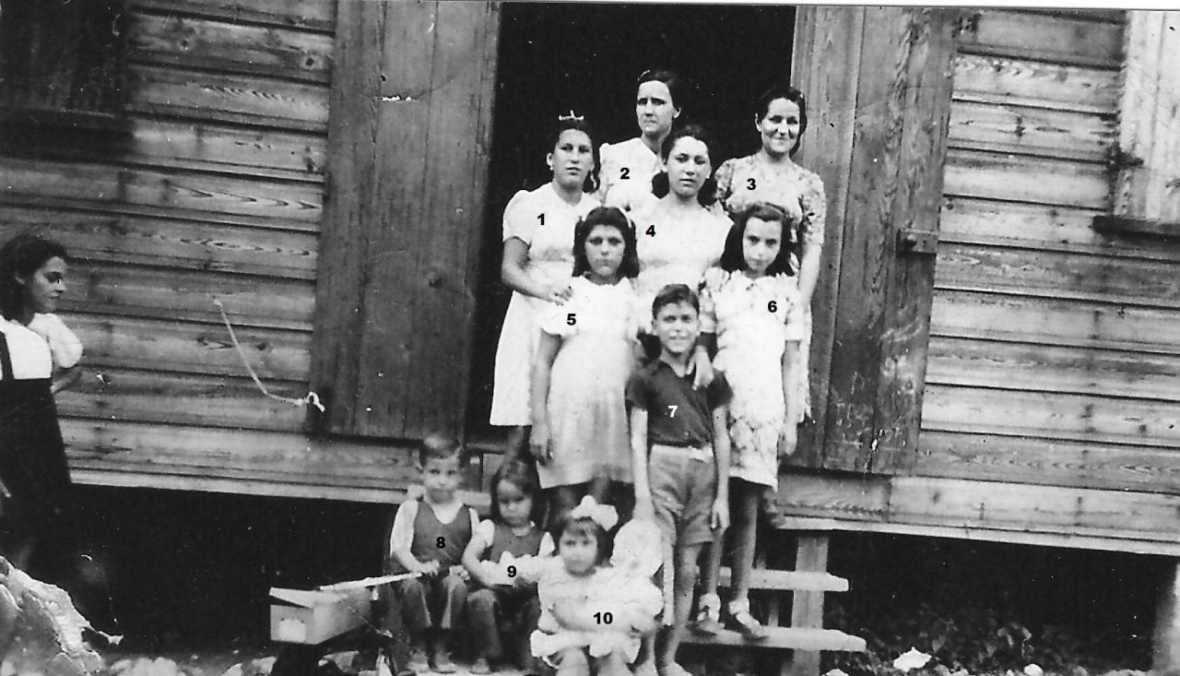
8.J.Enriles 9.R.Gilbert

