Ref L.3
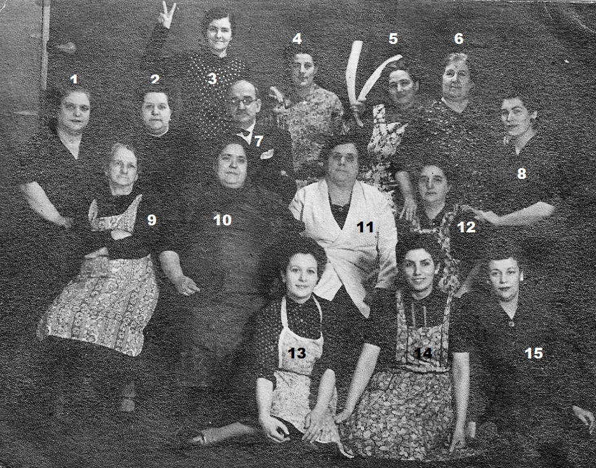
Kitchen workers at Marlborough Court
5. Mrs Kitty Cavilla, 6.Mrs Rogelia Gomez,7. Mr Alfredo Bugeja,rest not known.

Ref.L.4
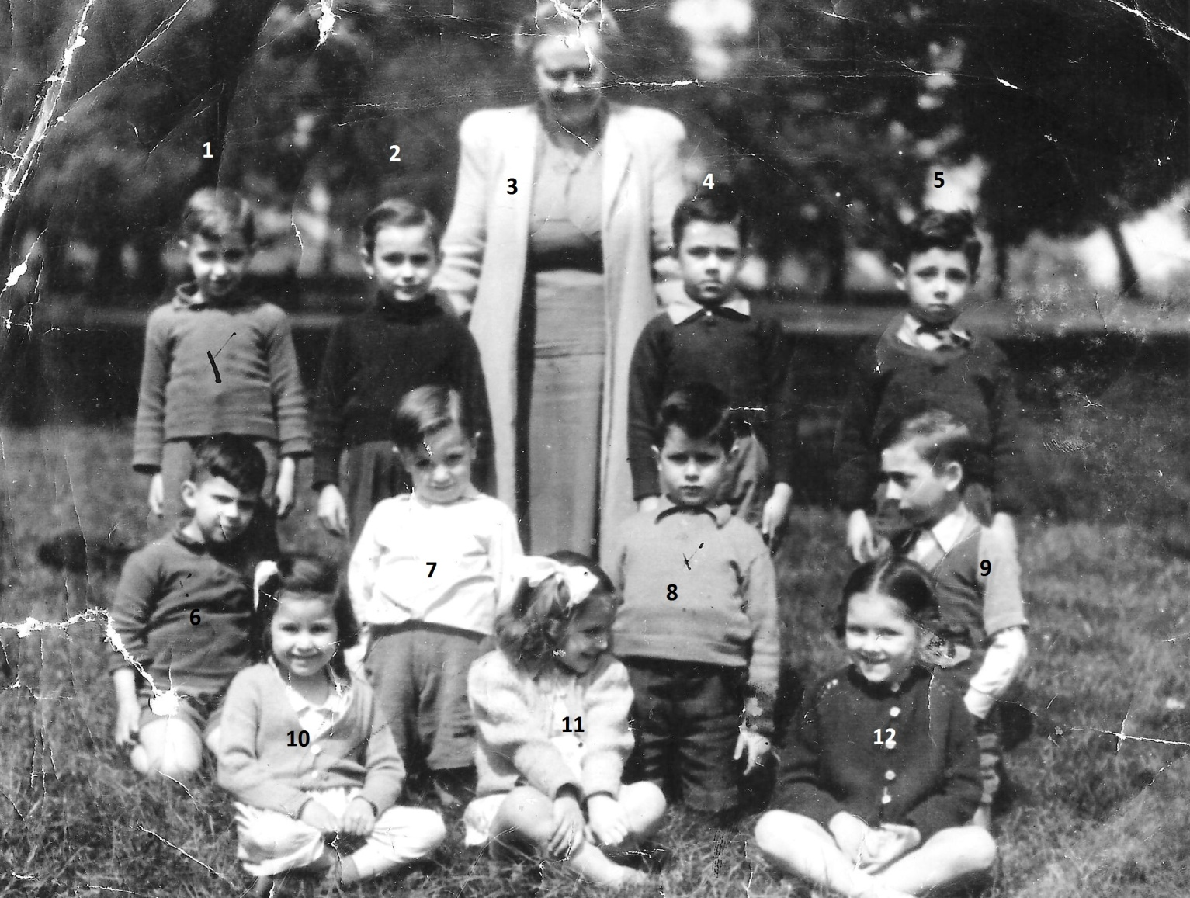
8. Johnny Tribello 9.Tito Vera, rest not known.

