Ref.L.9.
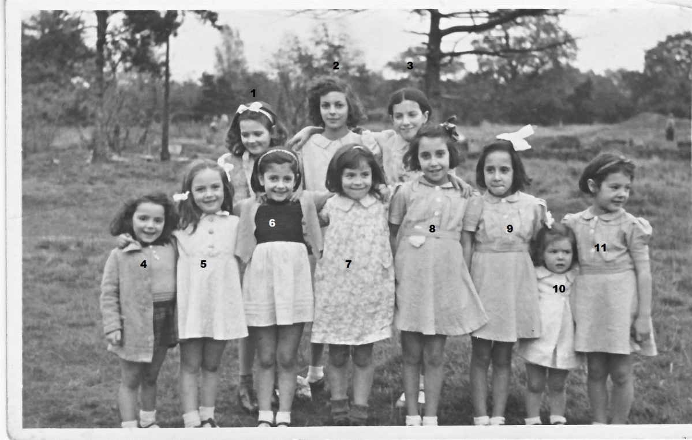
4. Madge Bosano 10. Dalmedo 11.Dalmedo, rest not known.

Ref.L.10.
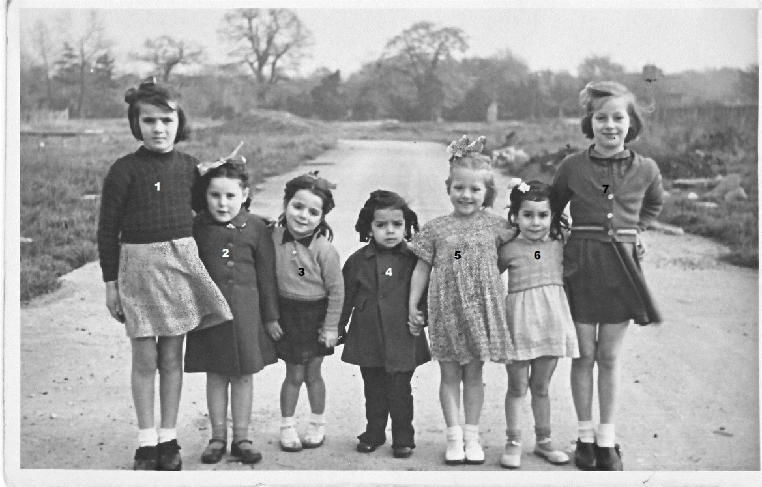
1. Isabel Rubio 2. Lily Colton 3.Madge Bosano, rest not known

