Ref.M.5
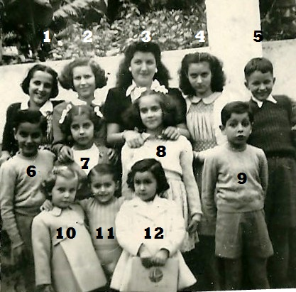
1.Aurelia Restano 2.Anita Restano 3.Lourdes Dotto 4.Teresa Pons 5. ? 6. ? 7 ? 8 ?..9. ?
10. Vivian Bassdone 11. Gerald Restano12.Ana Guillem.

Ref.M.6
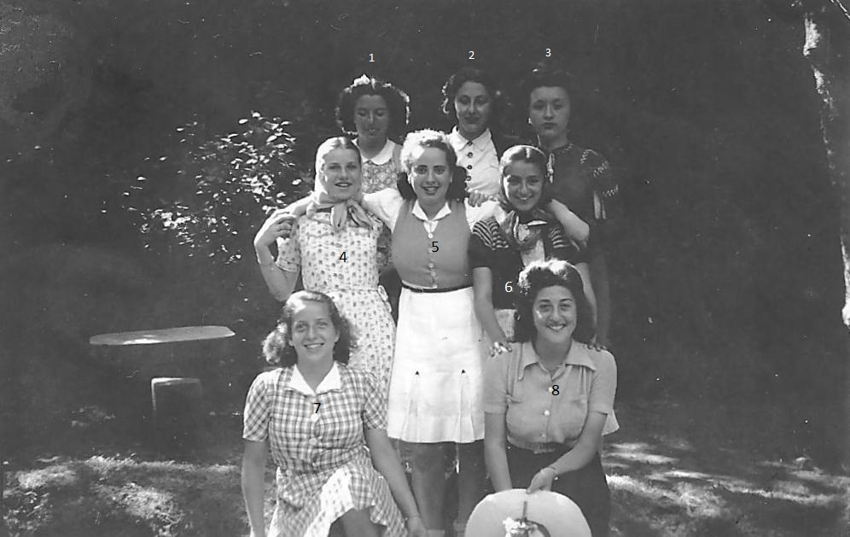
1 2 3 Alice O’Brien
4 Flavia Gracia 5 Carmen Rodriguez 6 Anita Alcantara 7 Irene de Torres 8 Norah Benzequen

