Ref.M.9.
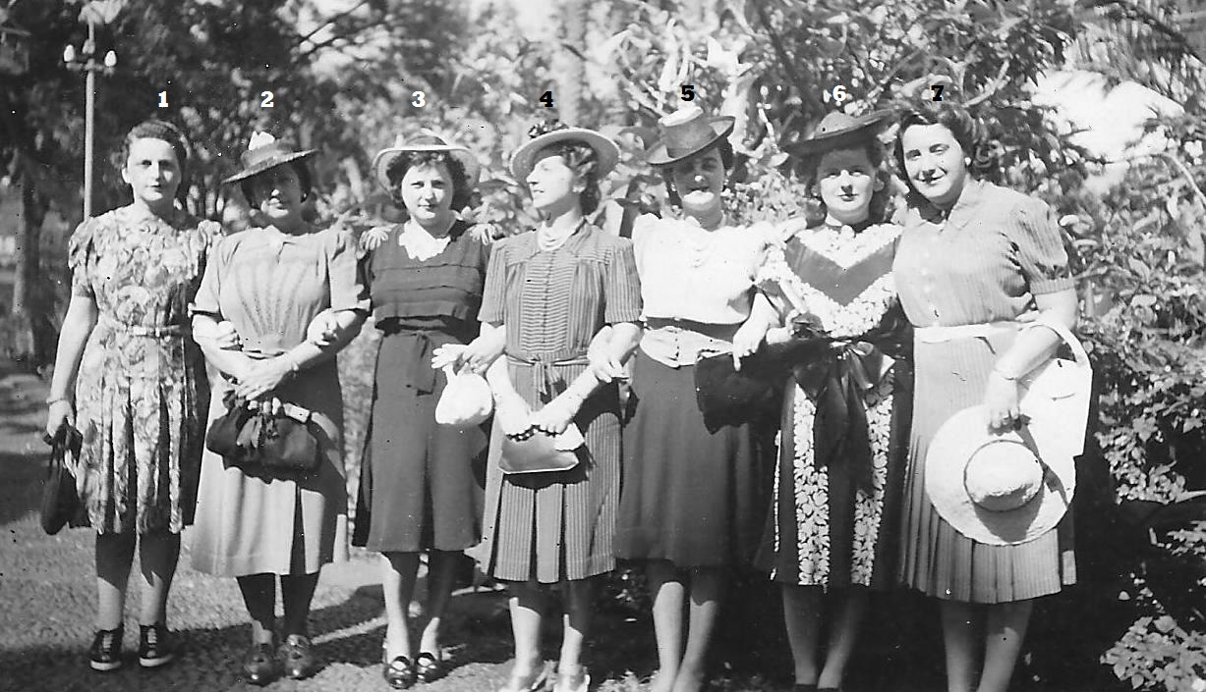
In the Golf Club Misses Balenci, A Canessa,

Ref.M.10.
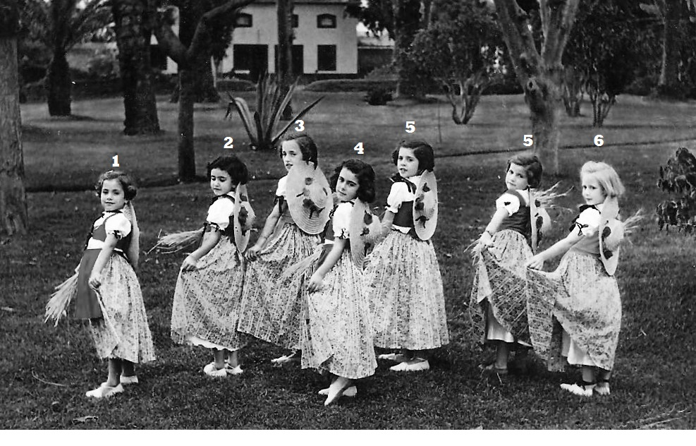
5.Ana Guillem rest not known

