Ref.J.1
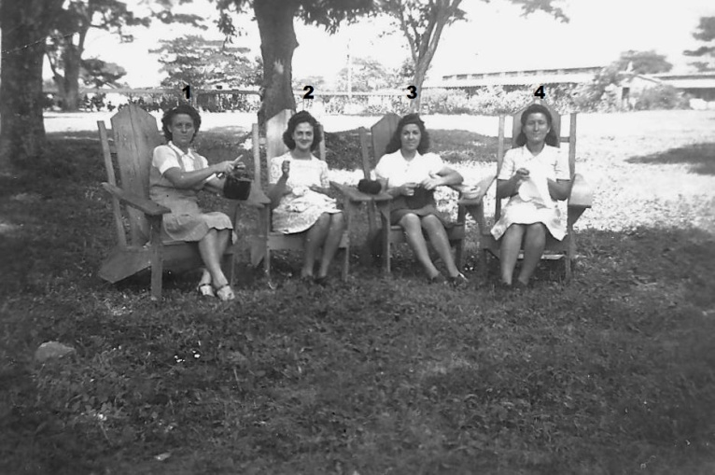
1. Horetencia Besura, 2.Olga Dalmedo 3. ....?..... 4. .......?......

Ref.J.2
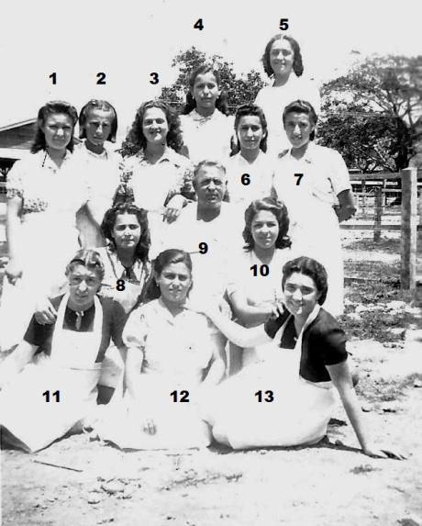
3.Olga Dalmedo, rest not known

