Ref.J.3
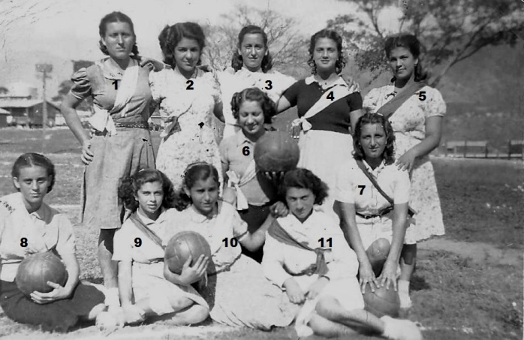
4.Olga Dalmedo 8.Hortencia Besura, rest not known

Ref.J.4
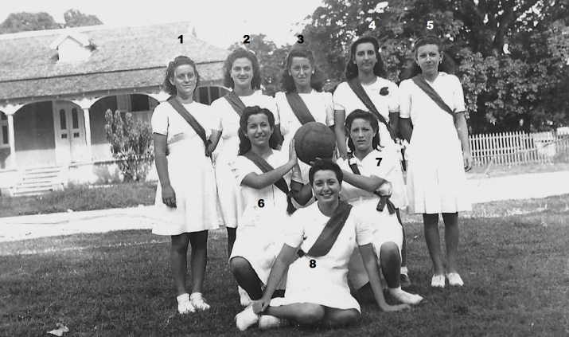
1. Hortencia Besura 2. Olga Dalmedo rest not known.

Ref.J.5
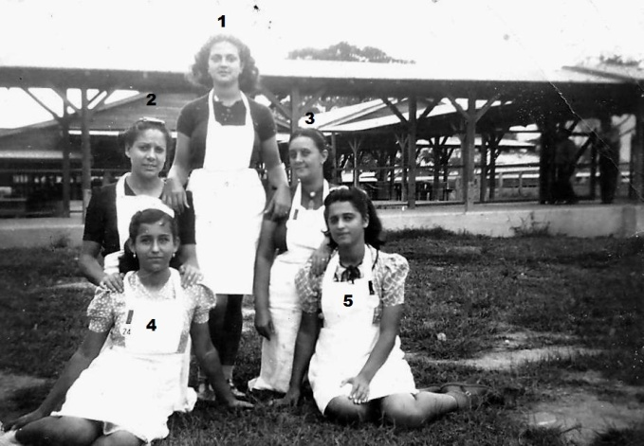
1. Olga Dalmedo rest not known.

