Ref.J.12
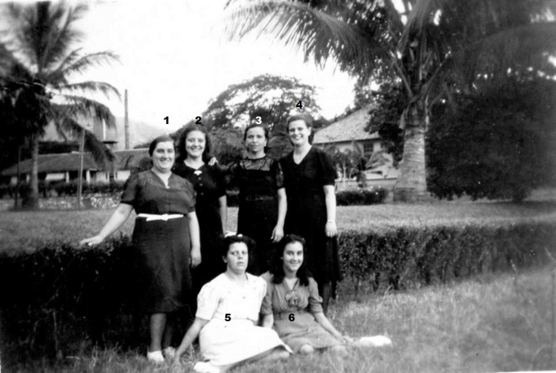
1. Mercedes Orcese 2. ? 3. ? 4. Mrs C Gomez 5. ?
6.Lourdes Orcese

Ref.J.13
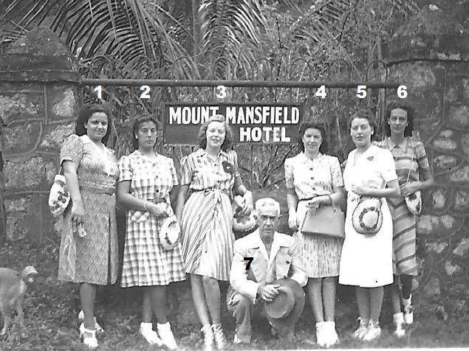
1.Mrs O Russo 2. Mrs E Borda 3 A.Villa 4.Mrs M Garro 5.Mrs Mizzi 6. ...?.... 7.

