Ref .J.17
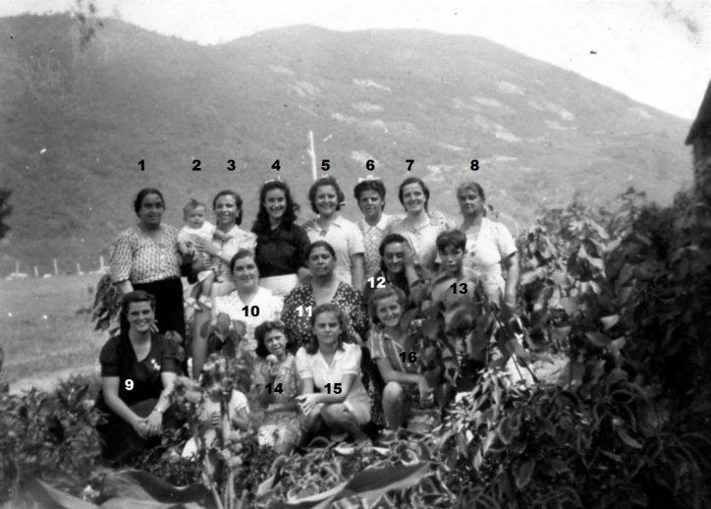
1.MrsR Orcese 4.L.Orcese 9. Mrs C Gomez 10.M.Orcese

Ref.J.18
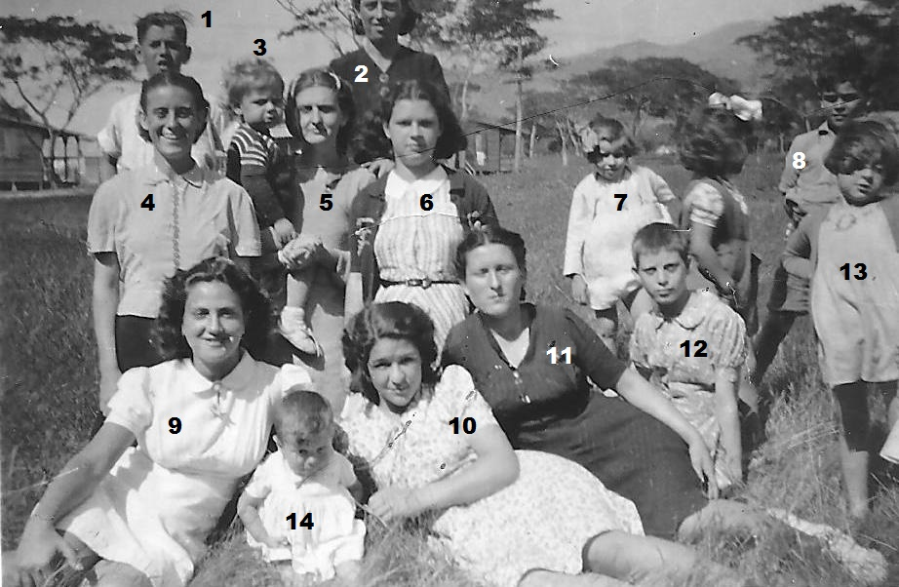
4. Hortencia Bensura 9. Olga Dalmedo Rest not known.

