Ref.J.19
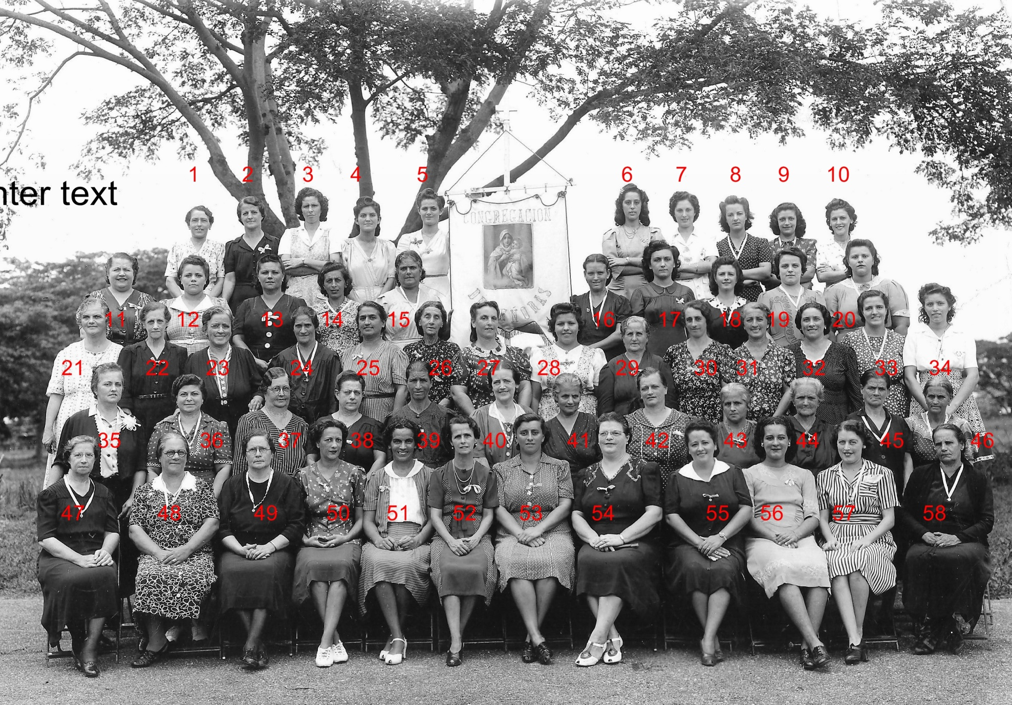

1 2 3 4 5 6 7 Isabel Hill 8 M.Garro 9 Anita Villa 10 11 12 13 14 15 16 17 18 Elma Wilkie( Nee Aposto) 19 Herminia Baldorino (Nee Graffioni) 20
21 22 23 24 25 Carlota Baker 26 27 28 29 30 Gracia Penalver?
31 32 33 Berta Gomez 34 35 36 37 38 39 40 Arsenia Villa
41 Carlota Lucia 42 43 44 Adamberry? 45 Maria Zammitt 46 47 48 Ernestina Cano(Nee Wood) 49 50
51 Lola Romero 52 Tucker 53 Matilde Ratcliffe? 54 Victoria Suarez 55 56 57 Isabel Mizzi 58

