Ref.L.5
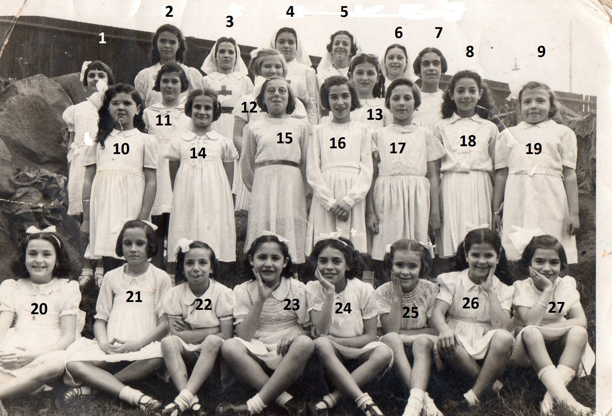
1 Sylvia Ashley5. Iris Arias 7. Maribel Garcia 12.Irma Pitto 13. Mary Holmes? 15. Emilia Desoiza? 16.Herminia Porro (nee Cohen) 18. Bautista 19.Lilian Apap 20. Josephine Holiday(nee Mania) 22. Frances Pitto(nee Bensusan) 24.Carmen Bruzon (nee Mannia) 26. Luisa Schembri (nee Fortunato) 25. Margot Marshall (nee Beacon) 27. Brenda Norton-Amor

Ref.L.6.
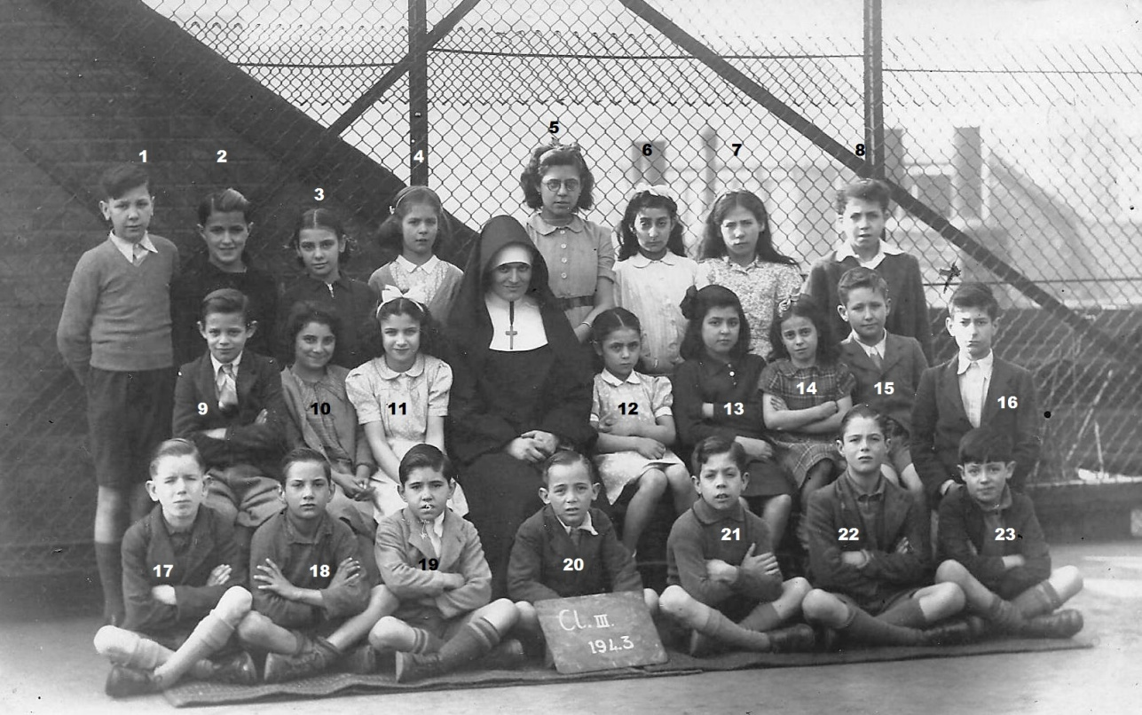
Children of Class III 1943 of St Patrick School near Warren Street Tube Station.
5. Dolores Vila (later Mrs Bosano), rest not known.

