Ref.L.7
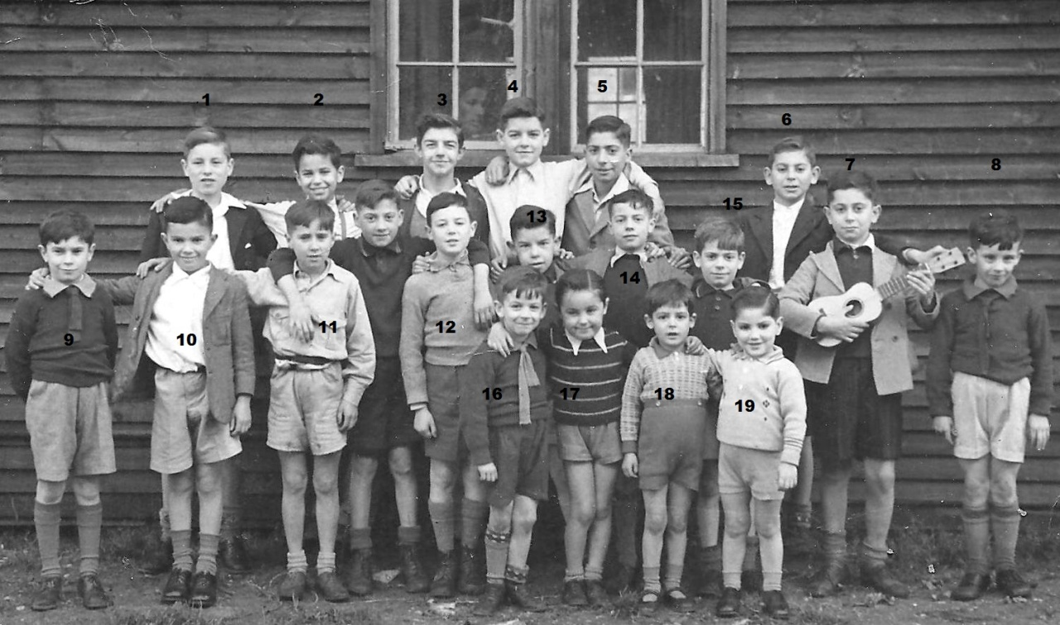
Children at Richmond
9. Salvador Pitaluga,rest not known.

Ref.L.8
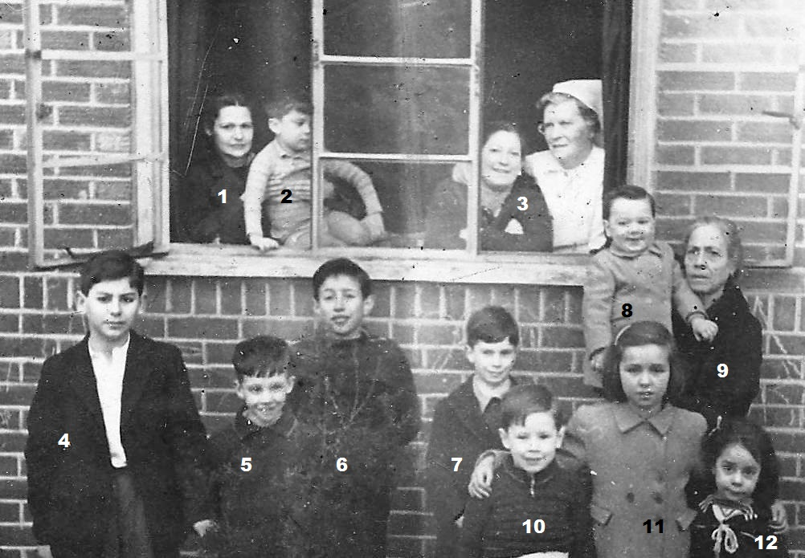
Evacuees in Courtlands Richmond .
11 Mary Cerisola,rest not known.

