Ref.L.15
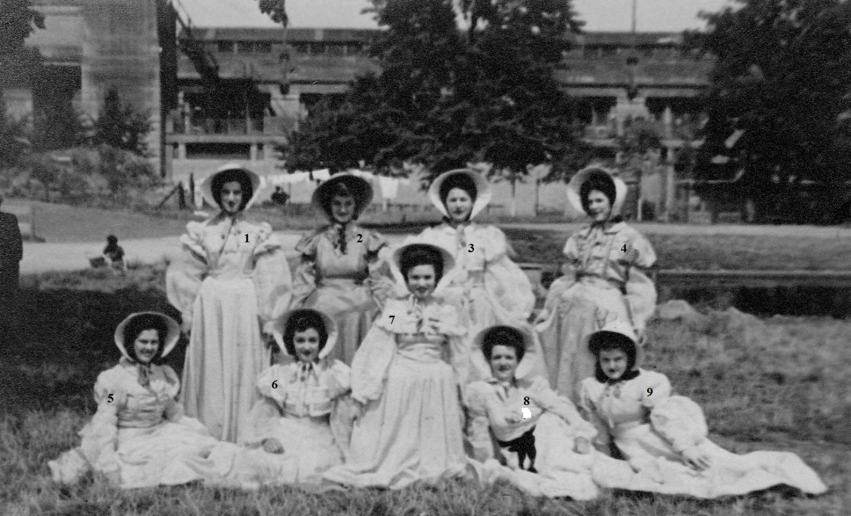

Ref.L.16
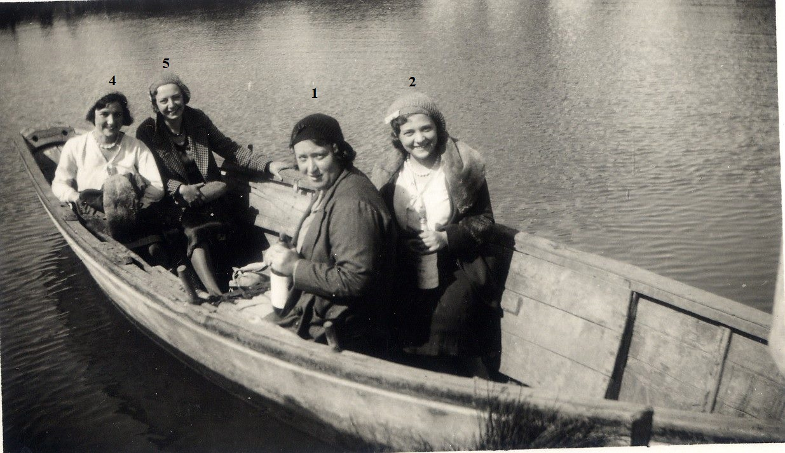
1.Mrs Byrne rest not known.

