Ref.N.2
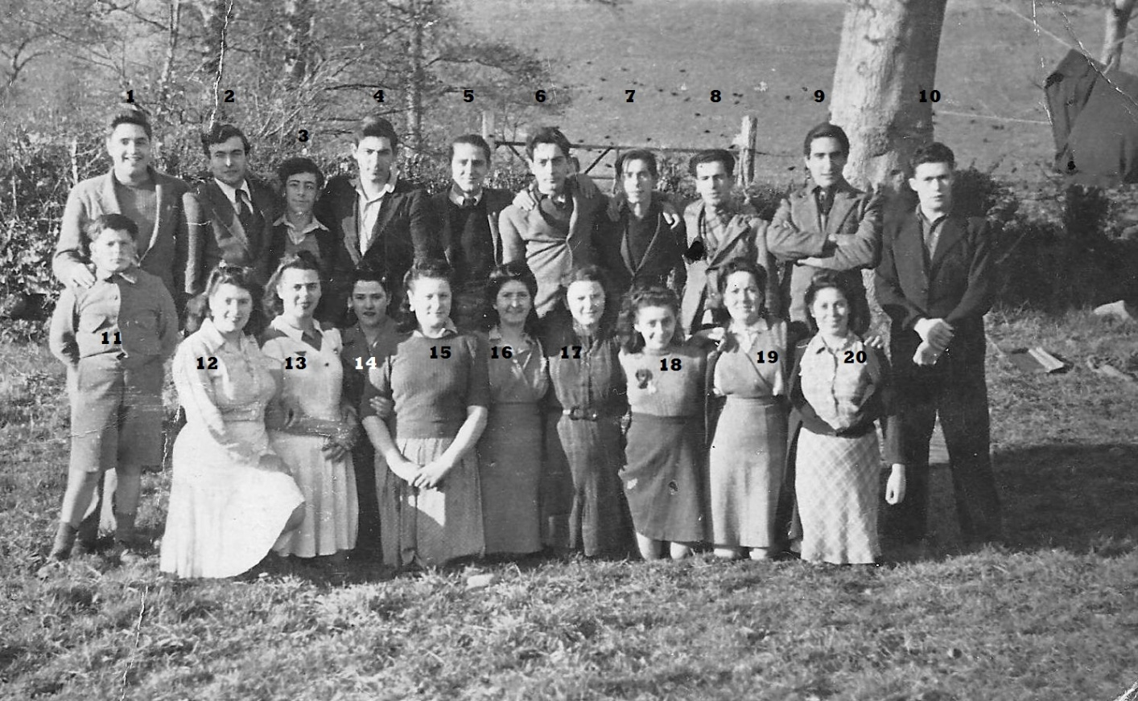
5 Aurelio Davis 8 Lionel Lezano 9 Rafael Celecia 10. Garcia 16. Laura Celecia

Ref.N.3
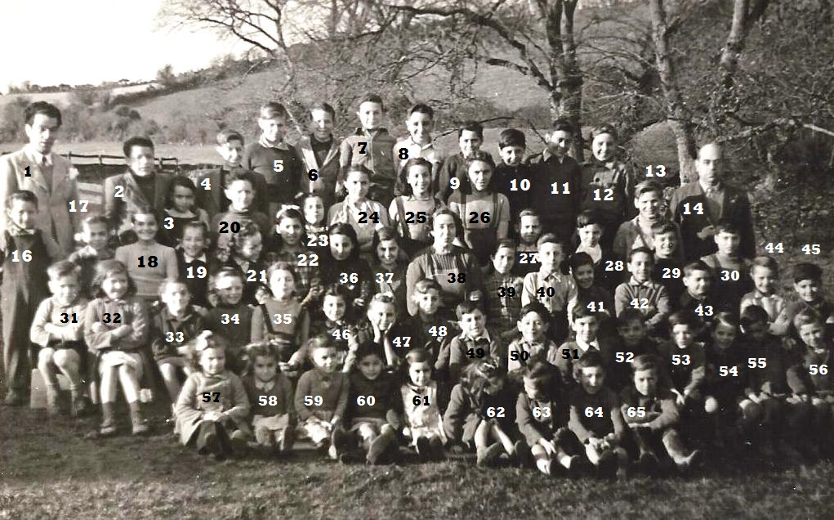
Gibraltarian Evacuee Children, Derry 1944.
8. Michael Baldachino 26. Maria-Angeles Picasso Margot Picasso (now Bottari) 51. Alfred Picasso

