Ref.N.6
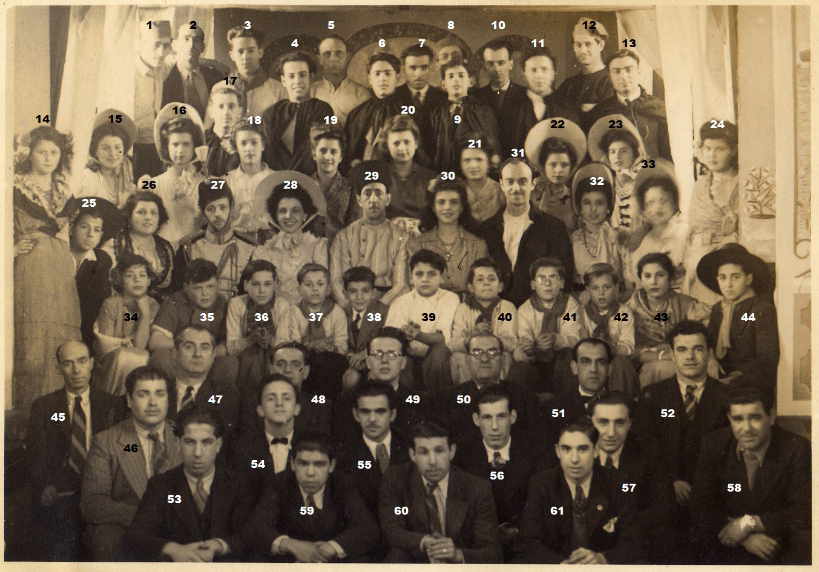
1.Charles Harrison 2. ? 3.James Kinder 4. Peire 5.Braulio Martinez 6.Luis Kinder 7.Antonio Almeida 8.?
9.Victor Sciacaluga 10.? 11.Alfonso Garcia 12.? 13.Pepe Moreno 14.Mary Burke 15.Hilda Peire 16.Maruja Macedo 17.Mario Sciacaluga 18.Teresa Alvarez 19.Elsie Sanchez 20.Rogelia Lavagna 21.Laurio MacEwen
22.Mary Grech 23.Violeta Alvarez 24.Ana Sufredo 25.Ocana 26.Elena Bado 27.Salvador Sciacaluga
28.Violeta Bado29.Salvador Holliday 30.Pepi Lavagna 31.Juan Bado 32.Aida Lavagna 33.Aida Ochelo
34. Olga Ocana 35.? 36.? 37.?38. Alfred Almeida 39.MacEwen 40.? 41. Morley 42.? 43.Ochelo 44.Octavio Victory 45.Antonio Lavagna 46.Jacinto Cabrera 47.Saccone 48.Antonio Victory 49. Fr Murphy 50.Juan Cruz
51. Harry Fernandez 52.Juan Ochelo 53.Ochelo 54. Tito Cruz 55.Tommy Estela 56. Walter Feetham
57.Lionel Victory 58.Antonio Ochelo 59.Tete 60.Manolo Gonzalez 61.Julio Alvarez.

