Ref.N.11
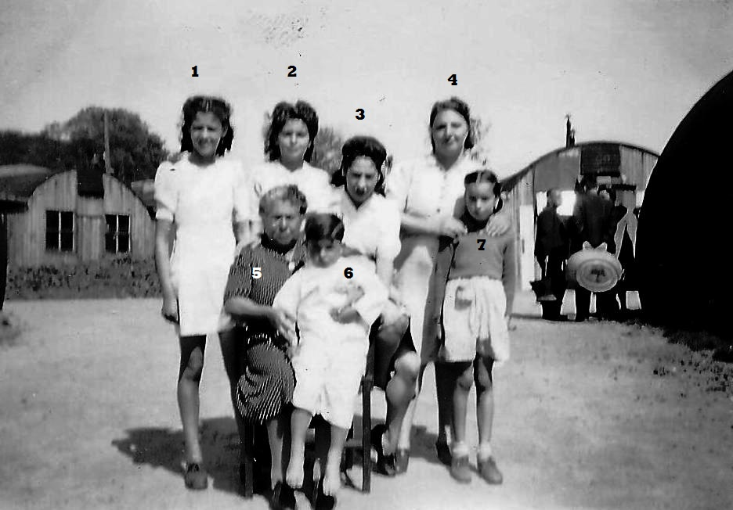
1...?..... 2.Idilia Navas 3....?.....,4...?......
5. Maria Sanchez 6....?....7 Gladys Power

Ref.N.12
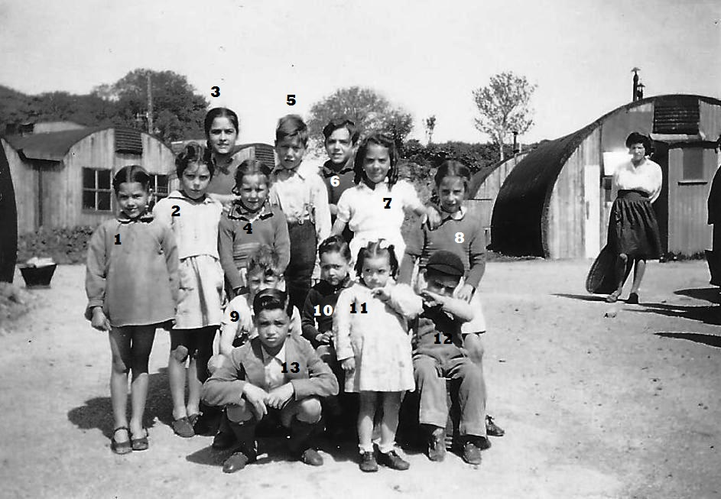
1....?....2 Andrea Ferro 3 ...?.... 4.Daisy Power 5.Eddie Power 6.....?... 7.Elena Bagna 8. ...?....9.Richard Power 10.....?........11....?.... 12....?.....13.....?.

